- Which of these areas was not inhabited by Native Americans?
  - the Great Plains
  - the Southern Highlands
  - the subarctic region
- Match tribes or locations to the correct dwelling.
  - the Inuit (3) c. the Pueblo People (2)
  - the Great Plains (4) d. Northwest (1)
1)
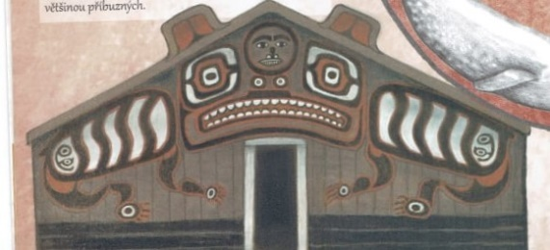
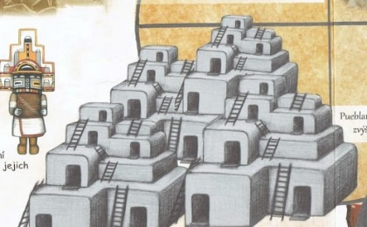
2)

- Which animal is not indigenous to North America?
  - horse b. coyote c. turkey
- Who won at Little Bighorn?
  - Native Americans b. the US army
- Which crop was not brought to Europe from North America?
  - potatoes c. corn
  - tomatoes d. buckwheat
- Which crop was brought to Europe from North America?
  - pumpkin b. rice c. barley
- Which animal did the Native Americans consider to be “the Trickster”?
  - snake b. coyote c. wolf
- What does the word “shaman” mean?
  - the wise one b. the magician c. the one who knows
- What did Native American women do when their husband died?
  - They would cut their hair.
  - They would stop eating for a week.
  - They had to marry again right away.
- Tattoos, among other things, were supposed to protect from illness.
  - true b. false
- Které z těchto míst Indiáni neobývali?
  - Velké planiny
  - Jižní vrchovina
  - Subarktické pásmo
- Přiřaď kmen nebo oblast ke správnému přístřeší.
  - Inuité (3) c. Pueblané (2)
  - Velké planiny (4) d. Severozápad (1)
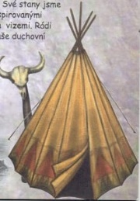
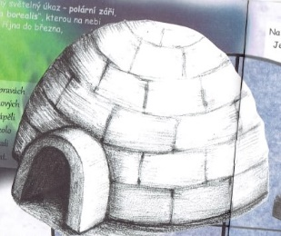
4)
3)

- Které zvíře není domorodé pro Severní Ameriku?
  - kůň b. kojot c. krocan
- Kdo vyhrál v bitvě u Little Bighornu?
  - Indiáni b. americká vojska
- Která potravina nebyla dovezena do Evropy ze Severní Ameriky?
  - brambory c. kukuřice
  - rajčata d. pohanka
- Která potravina byla dovezena do Evropy ze Severní Ameriky?
  - dýně b. rýže c. ječmen
- Které zvíře považovali Indiáni za „šibala“?
  - had b. kojot c. vlk
- Co znamená slovo „šaman“?
  - mudrc b. kouzelník c. ten, kdo ví
- Co dělaly indiánské ženy, když jejich manžel zemřel?
  - Osříhaly si vlasy.
  - Týden nejedly.
  - Hned se musely znovu provdat.
- Tetování, mimo jiné, mělo ochraňovat před nemocemi.
  - pravda b. lež

