Zvířata a totem

Stanoviště 1

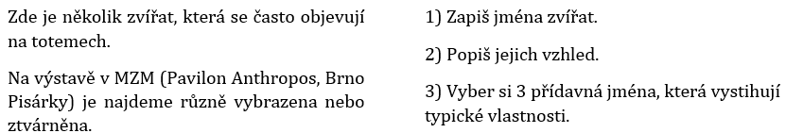

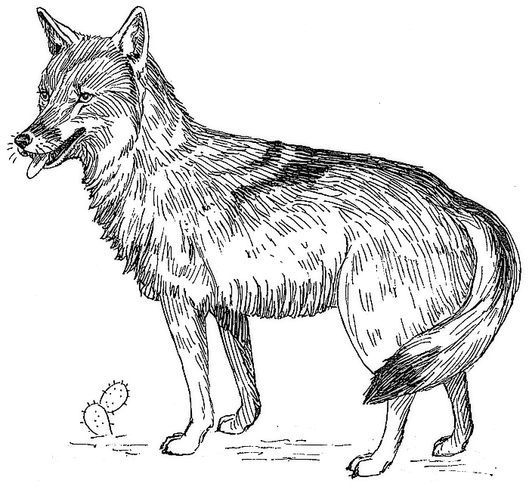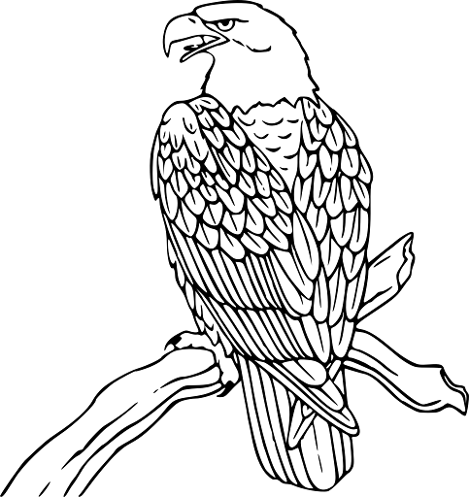

- 2.
________________________________ ________________________________

________________________________ ________________________________

________________________________ ________________________________

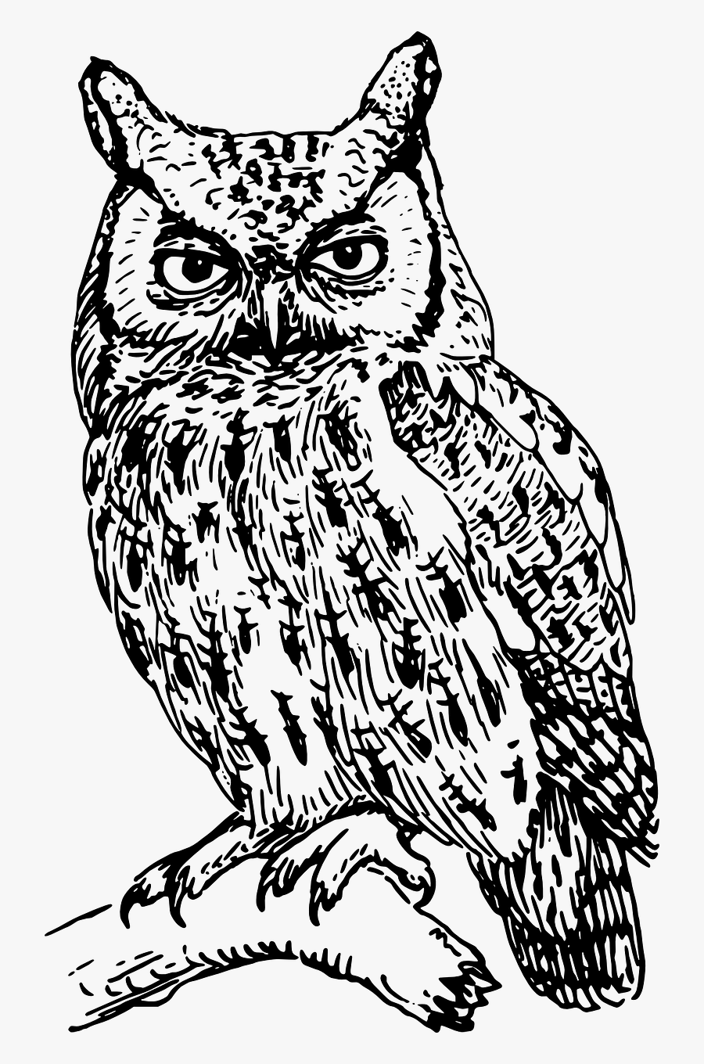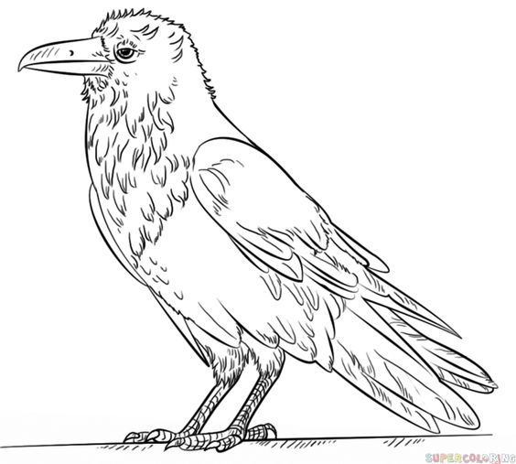
3. 4.
________________________________ ________________________________

________________________________ ________________________________

________________________________ ________________________________

Zvířata a totem

5.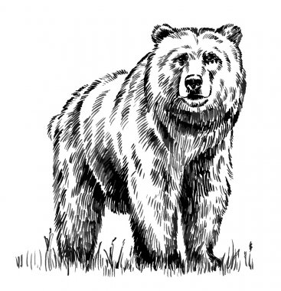 6. ________________________________ ________________________________

________________________________ ________________________________

________________________________ ________________________________

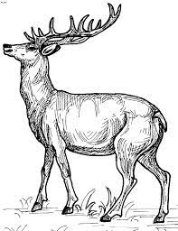

7- 8.
________________________________ ________________________________

________________________________ ________________________________

________________________________ _______________________________

Zvířata a totem

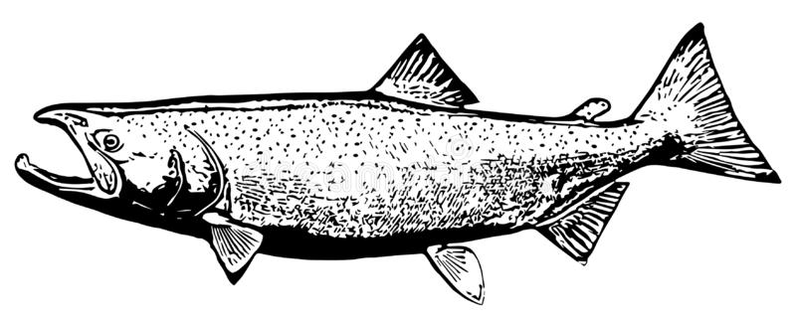

9. 10.
________________________________ ________________________________

________________________________ ________________________________

________________________________ ________________________________

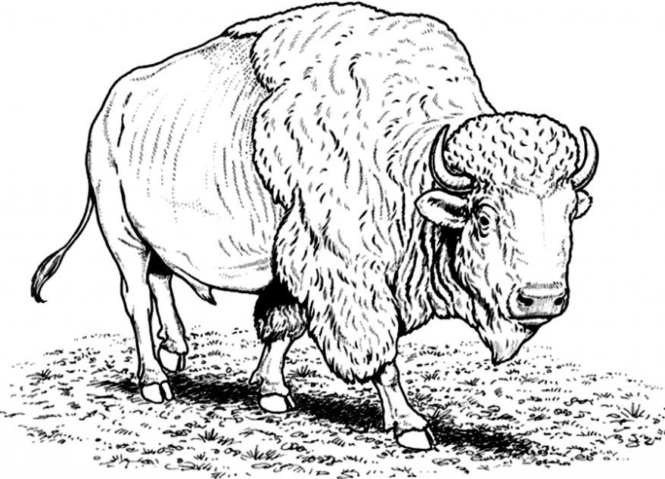
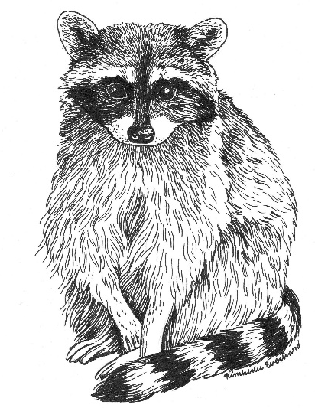

11. 12.
________________________________ ________________________________

________________________________ ________________________________

________________________________ ________________________________

