- Which of these areas was not inhabited by Native Americans?
  - the Great Plains
  - the Southern Highlands
  - the subarctic region
- Match tribes or locations to the correct dwelling.
  - the Inuit (3) c. the Pueblo People (2)
  - the Great Plains (4) d. Northwest (1)
1)
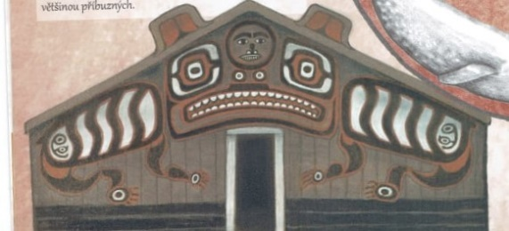
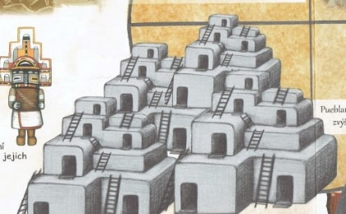
2)

- Which animal is not indigenous to North America?
  - horse b. coyote c. turkey
- Who won at Little Bighorn?
  - Native Americans b. the US army
- Which crop was not brought to Europe from North America?
  - potatoes c. corn
  - tomatoes d. buckwheat
- Which crop was brought to Europe from North America?
  - pumpkin b. rice c. barley
- Which animal did the Native Americans consider to be “the Trickster”?
  - snake b. coyote c. wolf
- What does the word “shaman” mean?
  - the wise one b. the magician c. the one who knows
- What did Native American women do when their husband died?
  - They would cut their hair.
  - They would stop eating for a week.
  - They had to marry again right away.
- Tattoos, among other things, were supposed to protect from illness.
  - true b. false
- Which of these areas was not inhabited by Native Americans?
  - the Great Plains
  - the Southern Highlands
  - the subarctic region
- Match tribes or locations to the correct dwelling.
  - the Inuit (3) c. the Pueblo People (2)
  - the Great Plains (4) d. Northwest (1)
1)
2)

- Which animal is not indigenous to North America?
  - horse b. coyote c. turkey
- Who won at Little Bighorn?
  - Native Americans b. the US army
- Which crop was not brought to Europe from North America?
  - potatoes c. corn
  - tomatoes d. buckwheat
- Which crop was brought to Europe from North America?
  - pumpkin b. rice c. barley
- Which animal did the Native Americans consider to be “the Trickster”?
  - snake b. coyote c. wolf
- What does the word “shaman” mean?
  - the wise one b. the magician c. the one who knows
- What did Native American women do when their husband died?
  - They would cut their hair.
  - They would stop eating for a week.
  - They had to marry again right away.
- Tattoos, among other things, were supposed to protect from illness.
  - true b. false

