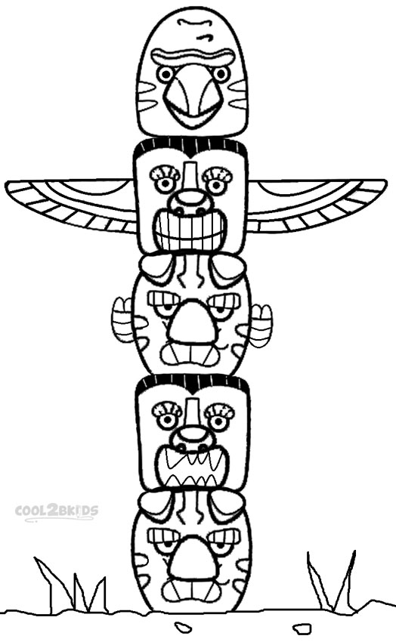
Instructions for colouring

one = yellow
two = red
three = blue
four = green
five = brown
six = black

