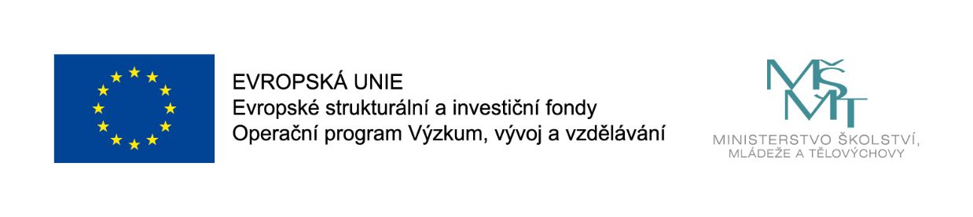
MUNI 4.0: Dangerous Times: The Implementation of Counter-Terrorism Policies in Educational Institutions
Sophia Butt
Datum: Thursday 10 September 17:15 – 17:45
Konference CercleS 2020: Centrum jazykového vzdělávání MU, Fakulta sociálních studií, Brno

Oral Presentation
At the 10th Wulkow Meeting in January 2018, language centre directors from the 11-member state countries met to discuss ways in which they could contribute to 'Language Teaching in Higher Education in Dangerous Times.' Among their key considerations was how professionals at such centres may be well-positioned to aid social cohesion, inclusivity and cultural sensitivity across Europe and beyond, despite increases in intercultural divisions fuelled by political decisions. One of the major policy changes that has emerged in many European and North American countries in recent years is the safeguarding role that is being introduced in the education sector to promote security and national identity. However, the implementation of counter-terrorism policies in the education sector has polarised the community: some practitioners argue that their role is to educate and not securitise, whilst other educationalists have willingly embedded policing practices into their classrooms.
In May 2015, the UK government launched a project named BRIT (Building Resilience through Integration & Trust) which includes a 'radicalisation-seeking' questionnaire aimed at primary schoolchildren. Introduced under the Prevent strand of CONTEST, the country's counter-terrorism strategy, the controversial questionnaire is based on a 2010 study by two psychologists with links to the national security industry: they examined prison inmates to determine the common risk factors associated with extremist offenders. Their now classified report contains 'a pre-crime intervention model' named Extremism Risk Guidance 22+ that formed the basis of the 'Vulnerability Assessment Framework' which was used to design questions for the BRIT questionnaire. Now, widespread implementation of WRAP (Workshops to Raise Awareness of Prevent) across every public service sector, including universities and language centres, is raising concerns as all personnel are subject to a statutory duty obligation "to have due regard to the need to prevent people from being drawn into terrorism" (section 26(1) of the Counter-Terrorism & Security Act 2015).
Canada has also adopted counter-terrorism measures under 'Prevent.' As government committees share scientific ideas and 'best practice', member states of the Wulkow Committee may soon be required to implement similar policies to combat radical ideologies. Therefore, this presentation will analyse the language of Prevent documents to determine whether they promote integration and trust, as claimed. The audience will then be asked to consider whether organisations such as the Wulkow Network might be in a position to aid national governments by offering to review and/or contribute to the wording of specific parts of national security policy documents.

Pracující ve všech sférách veřejného sektoru ve Velké Británii jsou ze zákona povinni, aby zabraňovali tomu, aby byli lidé zatahováni do terorismu. To zahrnuje vzdělávací průmysl, kde lidé od školek až po univerzity musí na sebe vzít roli pseudo protiteroristických úředníků. Není překvapivé, že dopady této kontroverzní politiky 'Prevence' polarizují společnost, zejména dochází k marginalizaci a ponižování jistých studentských komunit. Dále tvůrci politik v Evropě a Severní Americe sdílejí myšlenky a nápady na 'nejlepší praktiky' ve snaze potlačovat radikální ideologie ve vzdělávání.
Tato prezentace má za cíl kriticky analyzovat jazyk dotazníku (Prevent _and the _BRIT Questionnaire), aby se prověřilo, jak jsou v ní rámcově představeni sociální hráči, jmenovitě dospělí ve vyučovacím procesu a studenti. Účastníci budou požádáni, aby zvážili, zda organizace, jako např. Wulkow Network, by mohly pomoci národním vládám s nabídkou přeformulování znění konkrétních částí dokumentů týkajících se politiky národní bezpečnosti ještě před zavedením do praxe.
Sophia Butt joined the UK's University of Birmingham (UoB) in 1997 as a course writer for their distance MA in Translation Studies. From 2008-2014, she was director of the Business Management English Presessional Programme. As an interdisciplinary doctoral researcher working with Linguistics, Social Policy and Law, Sophia is currently exploring the implementation of the UK's counter-terrorism strategy in the education sector. She is also affiliated to Aalto University, Finland (2006- ) and Trinity College London (2015- ). Throughout 2019, Sophia provided consultancy to the Kazakh Ministry of Education as Vice Rector for Internationalisation at Suleyman Demirel University in Almaty.

