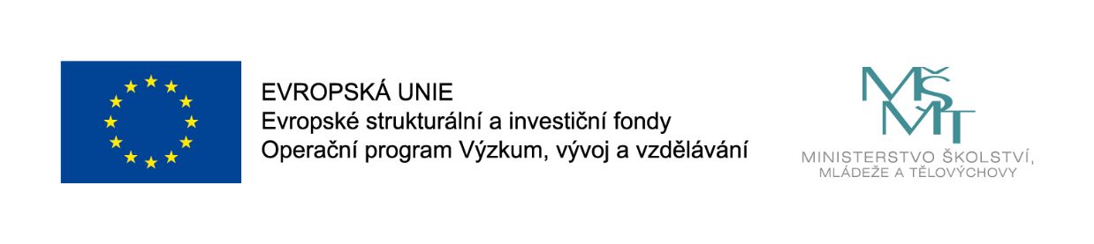
MUNI 4.0: Stimulate your metaphorical thinking: Workshop
Samuel Lagier
Datum: Friday 11 September 16:05 – 16:35
Konference CercleS 2020: Centrum jazykového vzdělávání MU, Fakulta sociálních studií, Brno

Workshop
Metaphors are more than sophisticated poetic embellishments – they shape our everyday lives in the way we speak, understand and act. A metaphor is a gateway between a known concept and a new dimension: it is this collision between disparate ideas that can transform confusion into comprehension. In this workshop, participants will explore this potential and create targeted metaphors.
After a brief theoretical introduction on metaphors, participants will create their very own metaphors to shed light on the concept of their choice. As opposed to Stimulate your metaphorical thinking, this workshop is about the creation and evaluation of targeted metaphors. This workshop is designed as a follow-up of the session Stimulate your metaphorical thinking yet it is not a requirements for participants to attend both workshops.
Activities during this workshop will happen in pairs, in small groups and with all the participants.
Questions for discussion:
How often do you use metaphors in your work?
Do you wish you could come up with more metaphors to explain things at work?
References:
- Metaphors we live by, George Lakoff and Mark Johnson

Dr Samuel Lagier is a scientist and a comedian. He specializes in communication, collaboration and creativity. He runs SamSpeaksScience, dedicated to help researchers talk about their work. Sam joined the TEDxLausanne team for 6 years as a curator, coach and host. He brings storytelling to experts for them to effectively share their rational, factual and thorough vision of the world to society. Sam holds a PhD in neuroscience and his 15 years of scientific research made him an expert in the exploration of complex systems, processes and ideas.
With over 13 years of experience with improvised comedy, he gives a serious playful twist to his experiential trainings. Learning is most effective through action and his situation-based activities provide the ideal platform for participants to understand the necessary ingredients for efficient collaboration and co-creation.

