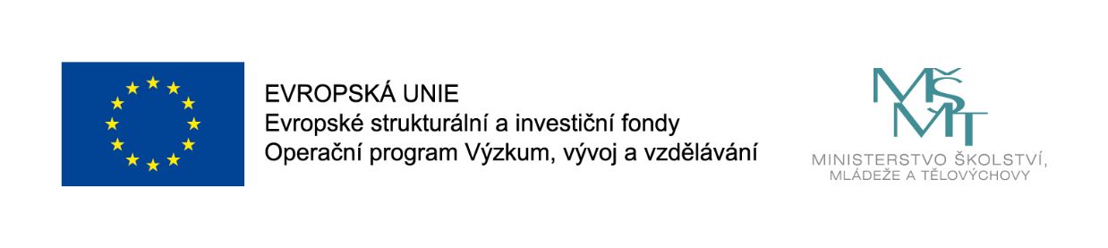
MUNI 4.0: Unleash your creative power: Workshop
Samuel Lagier
Datum: Thursday 10 September 15:30 – 16:00
Konference CercleS 2020: Centrum jazykového vzdělávání MU, Fakulta sociálních studií, Brno

Workshop
Life is unpredictable, your peaceful lesson gets interrupted, your carefully planned meeting turns into an open conflict… there are countless situations when you need to adapt and think on your feet. Everybody has the power to do it, yet it takes courage to give space for your imagination, your intuition, your "gut" to express itself. During this workshop participants will work on silencing their inner critic to build trust in their capacity to generate original ideas.
Every participant will be invited to engage in simple, playful and experiential activities derived from improvised comedy. These activities will happen in pairs, in small groups and with all the participants with the same goal: getting out of your head. There is no need to be funny, creative or artistic to engage in the activities of this workshop. Spontaneity is very liberating and participants are likely to surprise themselves over the course of this session.
The workshop will be concluded by a discussion on the role of creativity in the professional life.
Activities during this workshop will happen in pairs, in small groups and with all the participants. Some exercises will be purely physical (e.g. walking around the room), some purely verbal (e.g. telling a story). Participants will spend most of the workshop on their feet rather than sitting.
Questions for discussion:
Do you consider yourself « creative » ? « spontaneous » ?
Does your work require you to be creative ?
Is their room for creativity in your workplace ? Is creativity a disruptive force ? if yes, is it a positive or a negative disruption ?
References:
- A few references to the work of Daniel Kahneman, psychologist and Nobel-prize winner. His book Thinking, fast and slow is a good introduction to his work.
Dr Samuel Lagier is a scientist and a comedian. He specializes in communication, collaboration and creativity. He runs SamSpeaksScience, dedicated to help researchers talk about their work. Sam joined the TEDxLausanne team for 6 years as a curator, coach and host. He brings storytelling to experts for them to effectively share their rational, factual and thorough vision of the world to society. Sam holds a PhD in neuroscience and his 15 years of scientific research made him an expert in the exploration of complex systems, processes and ideas.
With over 13 years of experience with improvised comedy, he gives a serious playful twist to his experiential trainings. Learning is most effective through action and his situation-based activities provide the ideal platform for participants to understand the necessary ingredients for efficient collaboration and co-creation.

