The Story of the Two Wolves
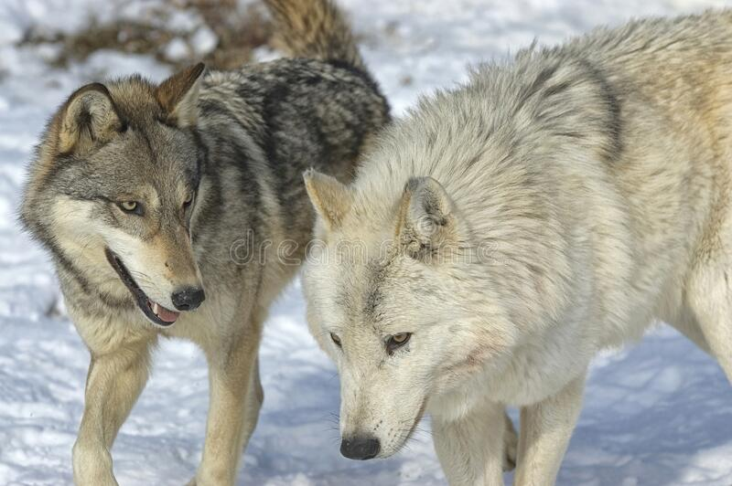
An old Cherokee is teaching his grandson about life.
“A fight is going on inside me,” he says to the boy.
“It is a terrible fight, and it is between two wolves. One is evil – he is anger, envy, sorrow, regret, greed, arrogance, self-pity, guilt, resentment, inferiority, lies, false pride, superiority, and ego.” He continues: “The other is good – he is joy, peace, love, hope, serenity, humility, kindness, benevolence, empathy, generosity, truth, compassion, and faith. The same fight is going on inside you – and inside every other person, too.”
The grandson thinks about it for a while. He is curious, so he askes his grandfather, “Which wolf will win?”
The old Cherokee simply replies: “The one you feed.
Exercises
- Put the verbs in bold letters in the past tense.

- For the following expressions find
- synonyms
Terrible | Fight | To continue
Simple | Life | To ask
Same | While | To feed

b) antonyms
Old | Life | To teach
Simple | Evil | To reply
Curious | While | To win

- What is the message of the story?

