___________________________________________________________________________

Explorers:

Educational Workshop
Let´s Explore Mexico
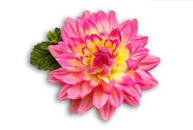

Name:
Group:

Program
- Presentations
Space for your notes. Put down anything that calles your attention:

- Workshop activities

Station 1: Indicate Mexico in the map. Name its neighbouring countries, where the majority of the population is Spanish speaking.

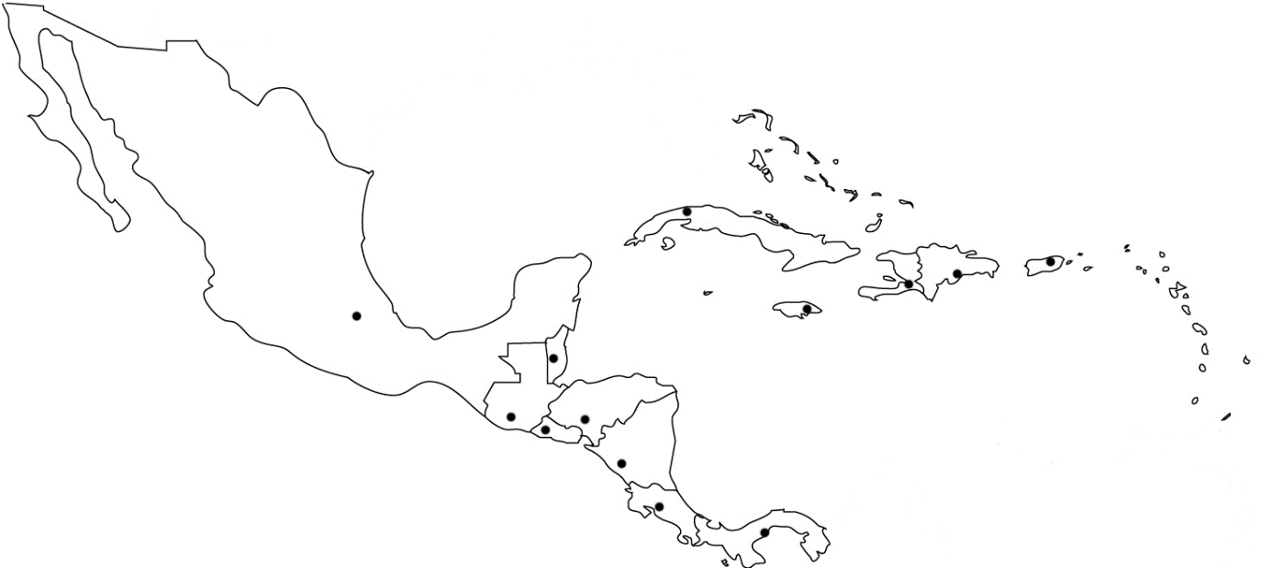
Station 2:
Make connection: link each country from Central America and the Caribbean with their capital cities.
- Argentina | - Santo Domingo
- Bolivia | - Guatemala City
- Dominican Republic | - Tegucigalpa
- Ecuador | - San Jose
- Guatemala | - Mexico City
- Honduras | - Bogota
- Chile | - San Salvador
- Columbia | - Buenos Aires
- Costa Rica | - La Paz
- Cuba | - Quito
- Mexico | - Santiago de Chile
- Nicaragua | - Panama City
- Panama | - Asuncion
- Paraguay | - Lima
- Peru | - Caracas
- Salvador | - Montevideo
- Uruguay | - La Havana
- Venezuela | - Managua

Listen and fill in the gaps. Use one word per gap.
Legend of La Llorona
A woman, wrapped in a flowing _______(1)_ and with her face covered with a veil, was slowly crossing several (2) ___________ and squares of the moonlit town. She raised her arms in anguish and launched a desperate (3)_______. That sad „oh!“ (4) __________ in the silence of the night, and then it disappeared among distant echoes, and finally it ended with the most mournful cry in the Plaza Mayor. That (5) mysterious _______ knelt there. She leaned over as if kissing the ground and wept with a piercing (6) _______ cry. Then she would go silently, slowly, until (7) ______________ to the lake, and on its shores she vanished. She disappeared in the air like mist, or sank into (8) _________.
(Source: adaptation from Profedeele.es, 2022)
Exercises:
a) Find synonyms of the words in italics
b) Find antonyms of the words in bold.
