Animals and Totems

Puesto 1

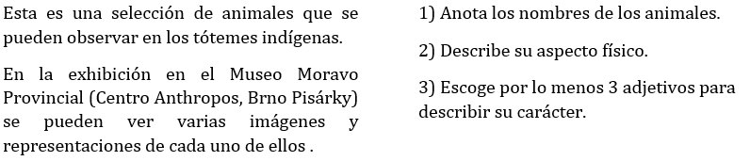
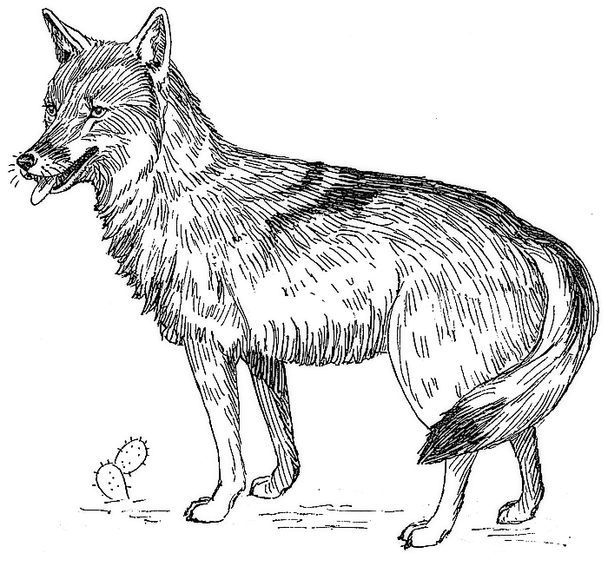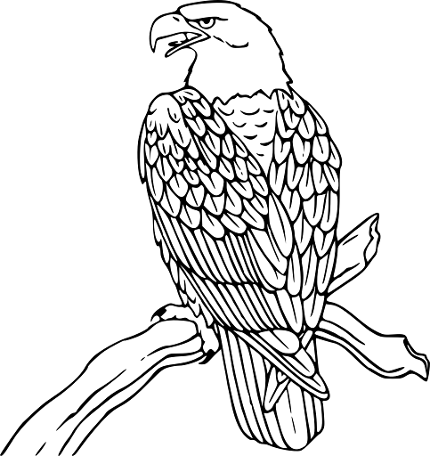

- 2.
________________________________ ________________________________

________________________________ ________________________________

________________________________ ________________________________

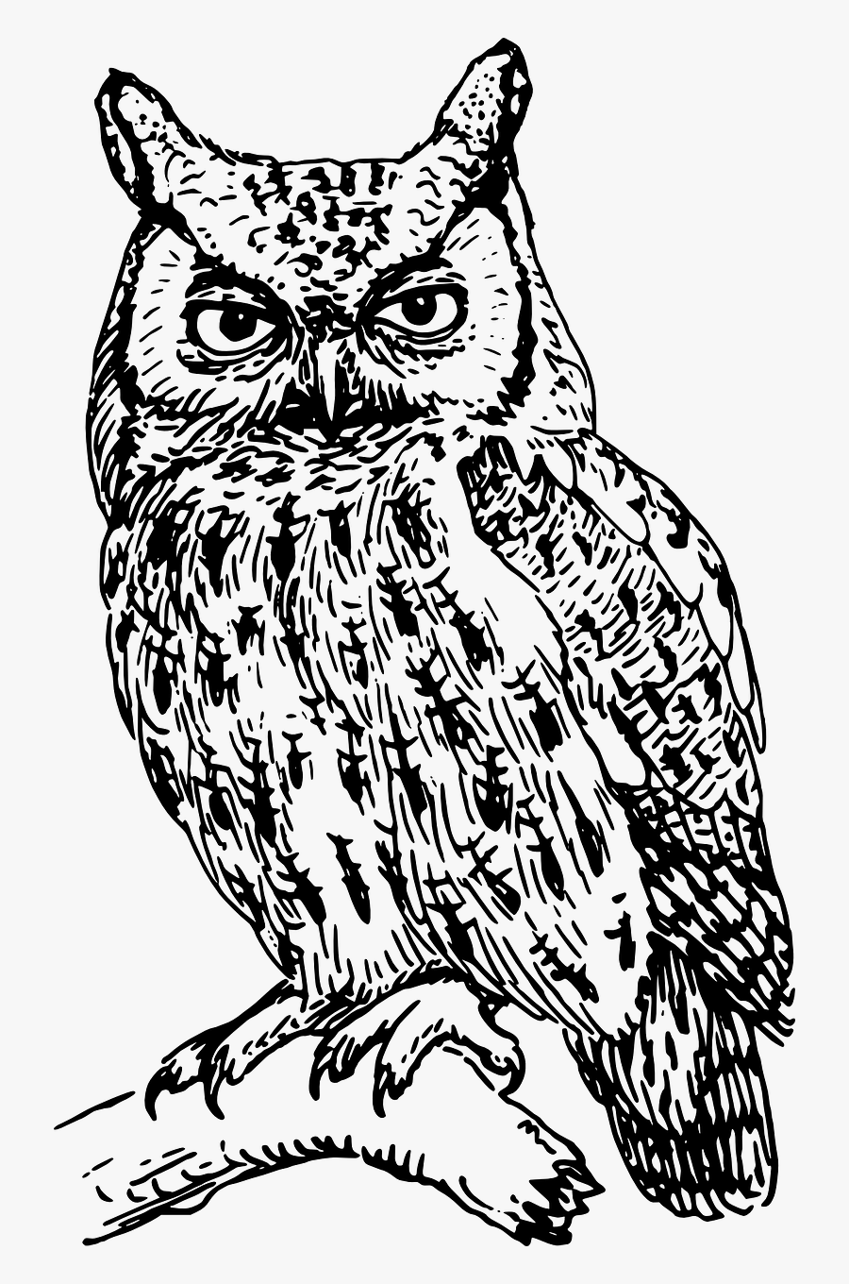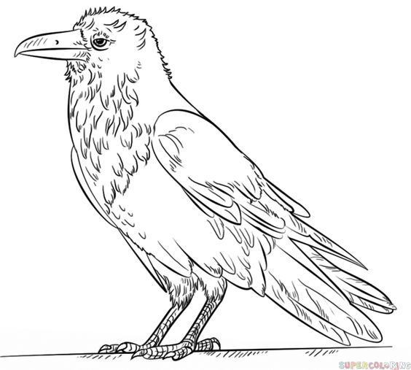
3. 4.
________________________________ ________________________________

________________________________ ________________________________

________________________________ ________________________________

Animales y Tótemes

5.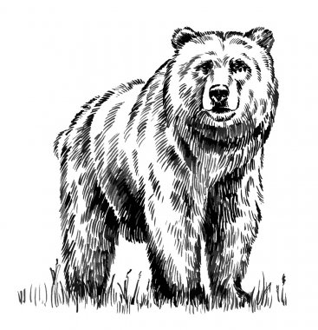 6. 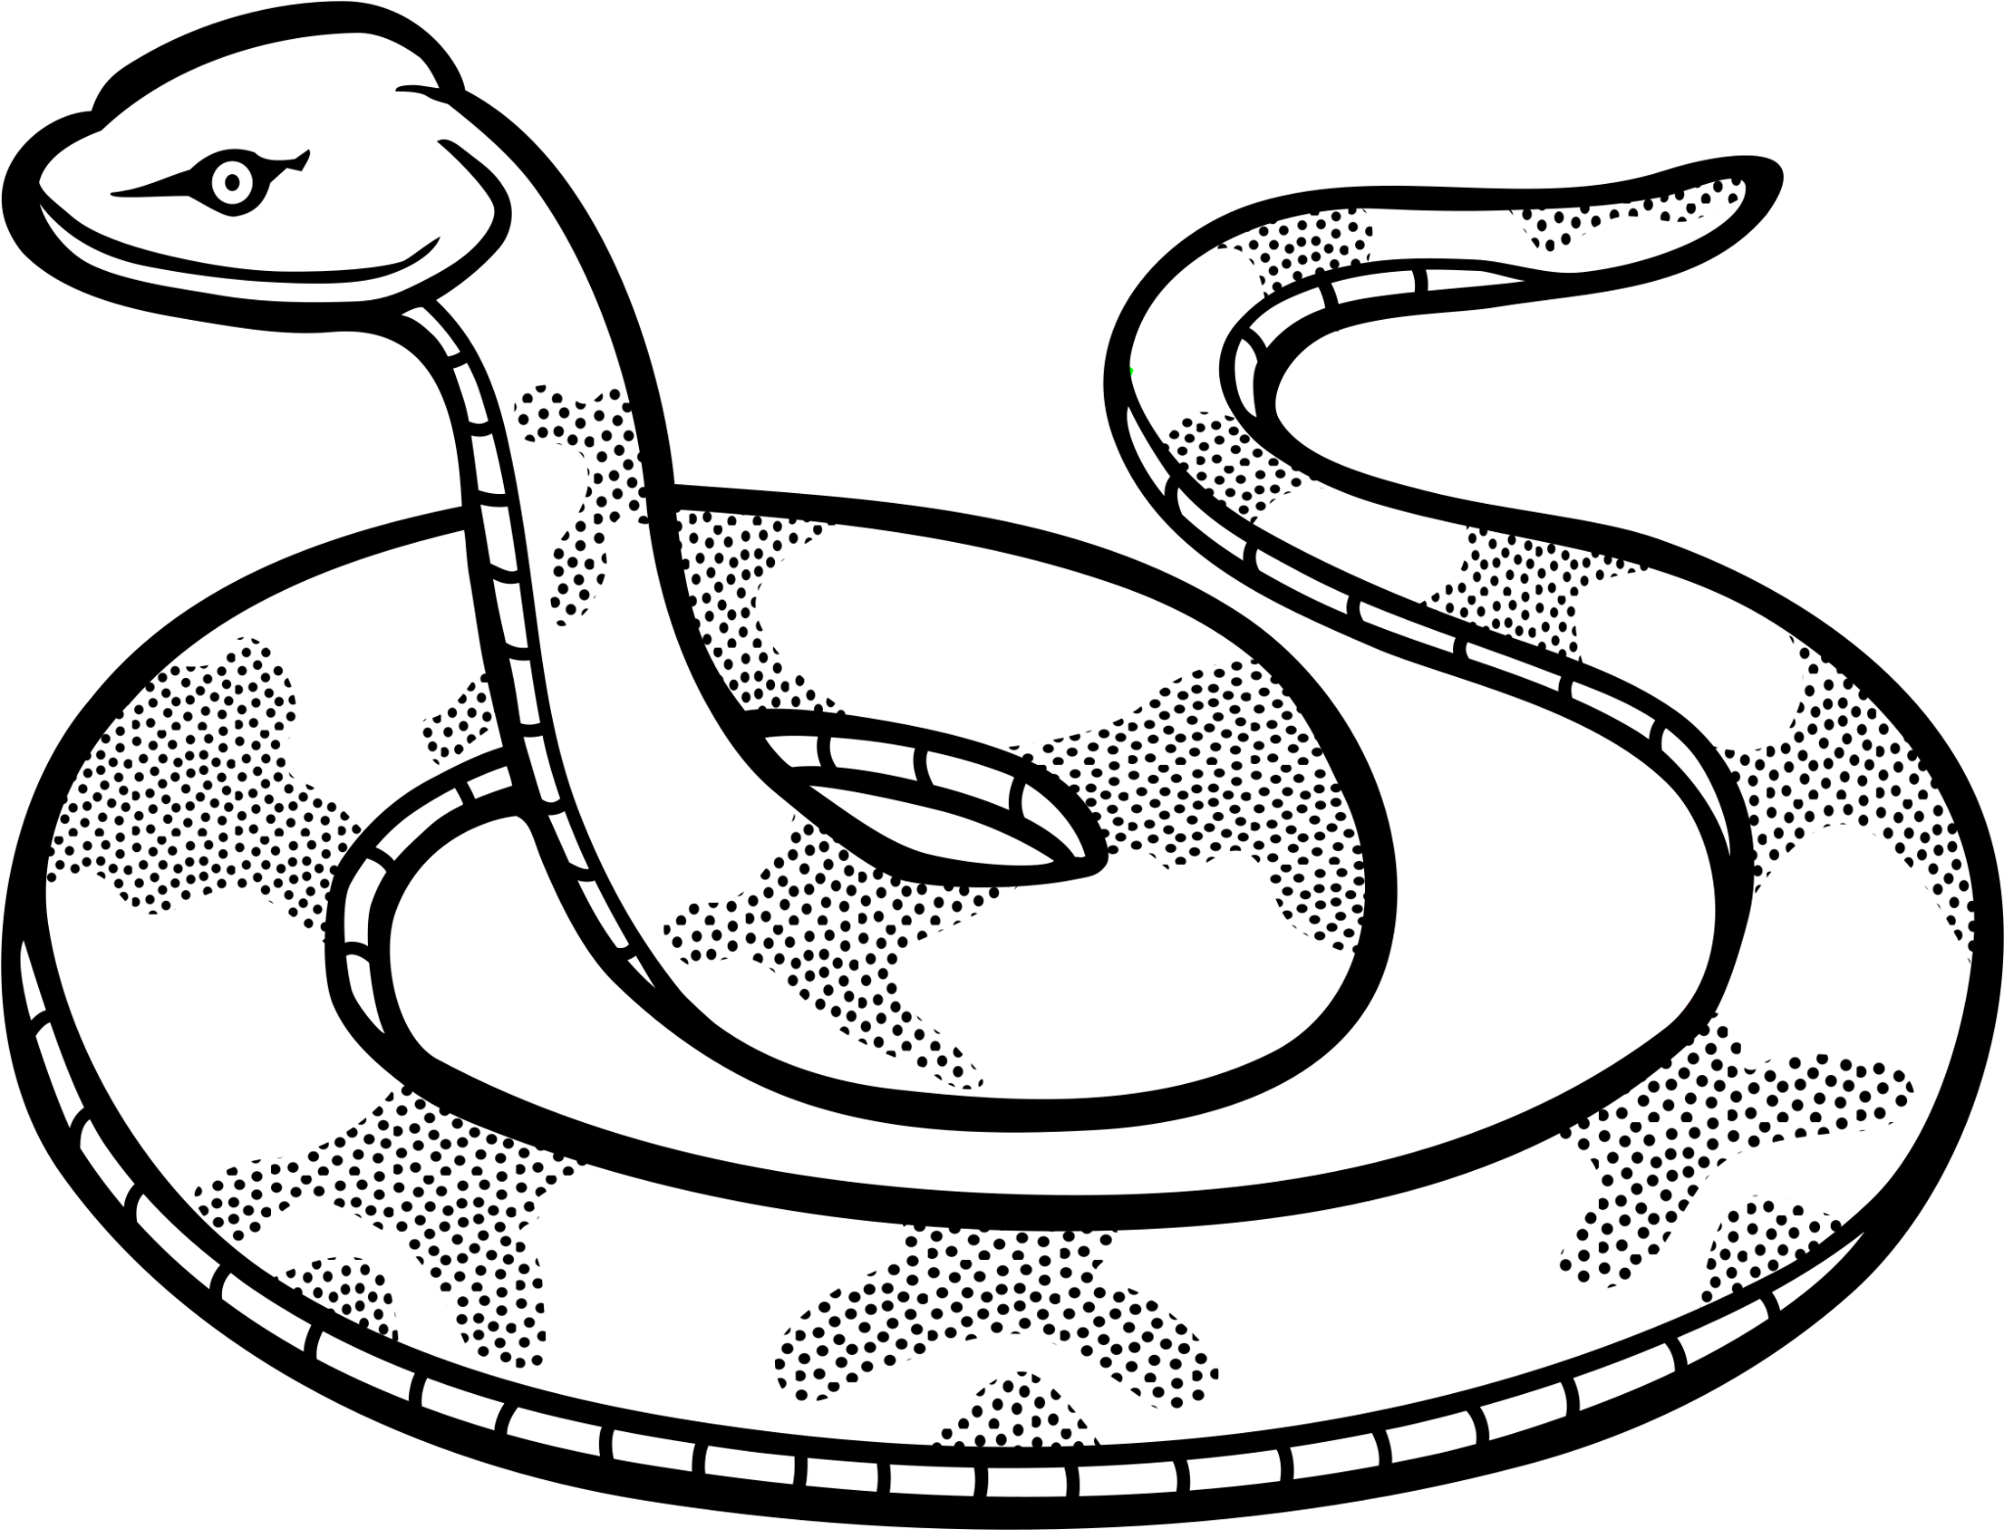________________________________ ________________________________

________________________________ ________________________________

________________________________ ________________________________

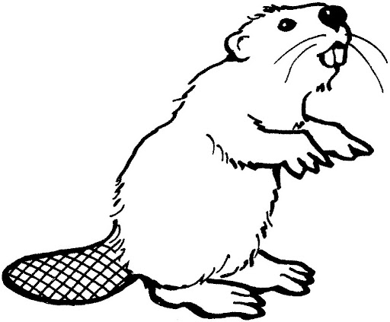
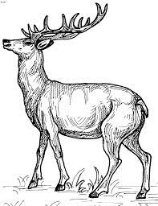

7- 8.
________________________________ ________________________________

________________________________ ________________________________

________________________________ _______________________________

Animals and Totems

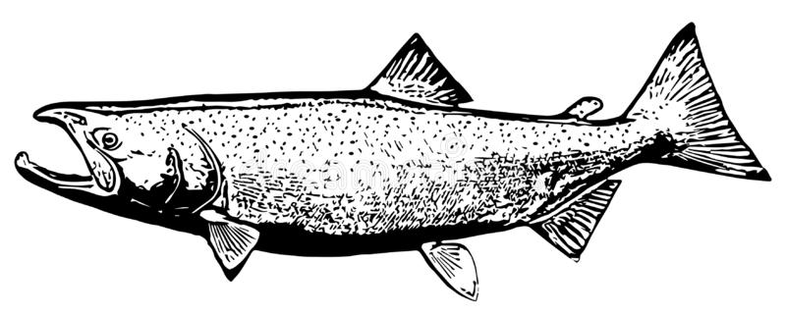

9. 10.
________________________________ ________________________________

________________________________ ________________________________

________________________________ ________________________________

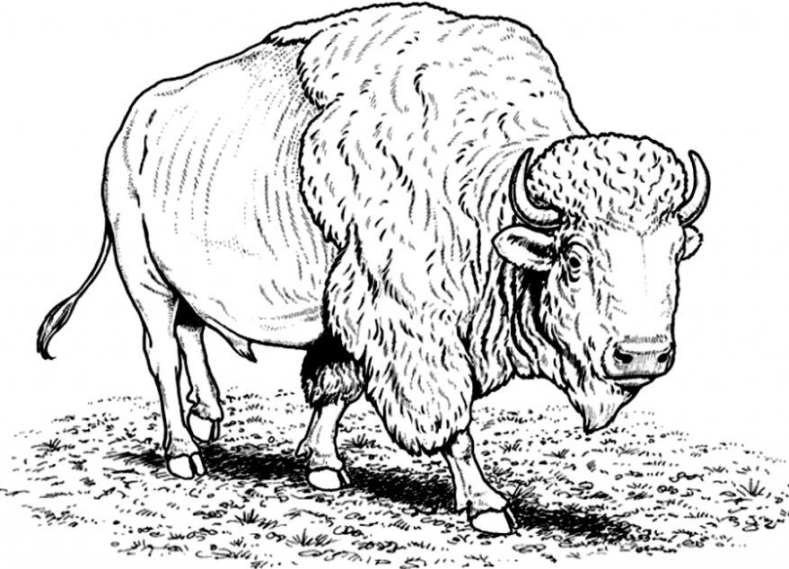
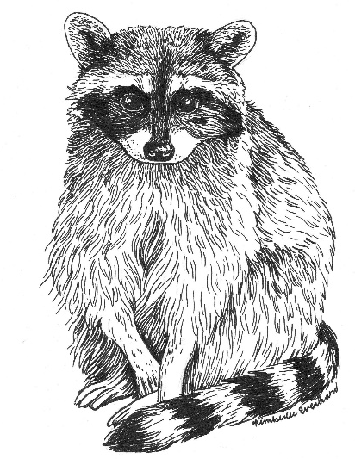

11. 12.
________________________________ ________________________________

________________________________ ________________________________

________________________________ ________________________________

